SMS SPAM DETECTION USING NLP CLASSIFICATION

A PROJECT REPORT

Submitted by

Shikhar Aasal
UID: 26BDA70036

in partial fulfillment for the award of the degree of

CS228:: B.E. (H) Computer Science in Data Science

IN
CSE Data Science


Chandigarh University | UIE, University of Engineering
December 2026
AI Applications | Section BDS-111 (A)



BONAFIDE CERTIFICATE

Certified that this project report entitled “SMS Spam Detection Using NLP Classification”, submitted by Shikhar Aasal (UID: 26BDA70036), is the project work completed for the AI Applications course under the guidance of Neeru Goel, UIE, University of Engineering, Chandigarh University.

SIGNATURE OF THE HEAD OF DEPARTMENT
SIGNATURE

Dr. Urvashi Garg (EF-1)

HEAD OF THE DEPARTMENT

UIE, University of Engineering
SIGNATURE OF THE PROJECT SUPERVISOR

SIGNATURE

Neeru Goel

PROJECT SUPERVISOR

UIE, University of Engineering

Submitted for the project viva-voce examination held on ____________________

INTERNAL EXAMINER EXTERNAL EXAMINER

CONTENTS

SECTION | TOPIC | PAGE
FRONT MATTER | Abstract | 1
FRONT MATTER | Graphical Abstract | 1
FRONT MATTER | Abbreviations | 1
FRONT MATTER | Symbols | 1
CHAPTER 1 | INTRODUCTION | 1
1.1 | Identification of Need and Contemporary Issue | 1
1.2 | Identification of the Problem | 1
1.3 | Identification of Tasks | 1
1.4 | Timeline | 1
1.5 | Organization of the Report | 1
CHAPTER 2 | LITERATURE REVIEW AND BACKGROUND STUDY | 1
2.1 | Timeline of the Reported Problem | 1
2.2 | Existing Solutions | 1
2.3 | Comparative Evidence Review | 1
2.4 | Review Summary | 1
2.5 | Problem Definition | 1
2.6 | Goals and Objectives | 1
CHAPTER 3 | DESIGN FLOW AND METHODOLOGY | 1
3.1 | Evaluation and Selection of Specifications and Features | 1
3.2 | Design Constraints | 1
3.3 | Analysis of Features and Finalization | 1
3.4 | Design Flow | 1
3.5 | Design Selection | 1
3.6 | Implementation Plan and Methodology | 1
CHAPTER 4 | RESULTS, ANALYSIS AND VALIDATION | 1
4.1 | Implementation of the Solution | 1
CHAPTER 5 | CONCLUSION AND FUTURE WORK | 1
5.1 | Conclusion | 1
5.2 | Future Work | 1
BACK MATTER | References | 1
APPENDIX A | Plagiarism Report | 1
APPENDIX B | Design Checklist | 1
APPENDIX C | Colab Run Instructions | 1
APPENDIX C | Colab Execution Evidence | 1

LIST OF FIGURES

FIGURE | CAPTION | PAGE
Figure 1 | Graphical abstract of the project workflow. | 1
Figure 2 | Implemented SMS spam detection methodology. | 1
Figure 3 | Dataset upload and class counts. | 1
Figure 4 | Stratified 80/20 train-test split. | 1
Figure 5 | Naive Bayes and Logistic Regression pipeline training. | 1
Figure 6 | Evaluation code used for accuracy, reports and confusion matrices. | 1
Figure 7 | Naive Bayes test results. | 1
Figure 8 | Naive Bayes confusion matrix and Logistic Regression accuracy. | 1
Figure 9 | Logistic Regression classification report. | 1
Figure 10 | Logistic Regression confusion matrix. | 1
Figure 11 | Predictions and estimated spam probabilities for sample messages. | 1
Figure 12 | Prediction for a user-entered SMS message. | 1

LIST OF TABLES

TABLE | CAPTION | PAGE
Table 1 | Proposed work plan to the approximate 16 December 2026 target. | 1
Table 2 | Comparative summary of selected sources. | 1
Table 3 | Project constraints and handling. | 1
Table 4 | Classifier design alternatives on the same split. | 1
Table 5 | Test-set performance and class-level error counts. | 1
Table 6 | Naive Bayes confusion matrix; rows are actual labels and columns are predicted labels. | 1
Table 7 | Logistic Regression confusion matrix; rows are actual labels and columns are predicted labels. | 1
Table 8 | Sample predictions generated by the fitted Naive Bayes model. Estimated probabilities are model scores for these messages. | 1

PROJECT STRUCTURE • SMS SPAM DETECTION

Constraint | Basis | Project relevance | Handling
Dataset scope | Kaggle CSV; 5,572 messages | One historical labelled corpus | Report test results only for this corpus
Class imbalance | 4,825 ham / 747 spam | Accuracy may hide missed spam | Show confusion matrices and spam recall
Privacy and ethics | Text-only offline notebook | SMS may contain personal details | Do not publish raw messages unnecessarily
Deployment | Class project prototype | No live phone integration | Describe mobile filtering as a possible use

Table 3. Project constraints and handling.

ABSTRACT
This project develops a supervised natural language processing (NLP) classifier for identifying SMS messages as spam or legitimate (ham). The Kaggle SMS Spam Collection CSV used in the experiment contains 5,572 messages: 4,825 ham and 747 spam. Messages are labelled as 0 for ham and 1 for spam. After a stratified 80/20 split, 4,457 messages were used for training and 1,115 for testing. TF-IDF converts message text into numerical features, and two scikit-learn pipelines compare Multinomial Naive Bayes with Logistic Regression. On the held-out test set, Naive Bayes achieved 96.86% accuracy and Logistic Regression achieved 96.77%. Their confusion matrices show no ham messages were incorrectly marked as spam in this split, while 35 and 36 spam messages respectively were missed. Naive Bayes was selected by the notebook’s accuracy comparison, though the 0.09 percentage-point difference is small and comes from one split. The result demonstrates a useful classroom baseline for communication filtering; it does not establish production-level performance on current messages.

GRAPHICAL ABSTRACT
The workflow converts labelled messages to TF-IDF features, trains two classifiers, and evaluates predictions on held-out messages.
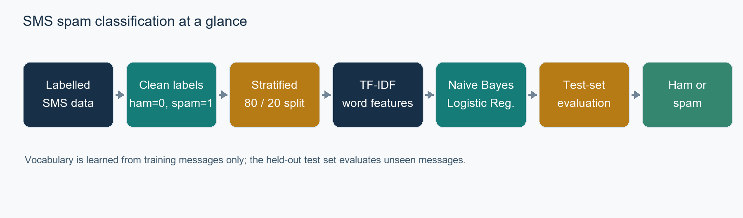
Figure 1. Graphical abstract of the project workflow.

ABBREVIATIONS
AI - Artificial Intelligence; CSV - Comma-Separated Values; ham - legitimate SMS; IDF - Inverse Document Frequency; LR - Logistic Regression; ML - Machine Learning; NB - Naive Bayes; NLP - Natural Language Processing; SMS - Short Message Service; TF - Term Frequency; TF-IDF - Term Frequency-Inverse Document Frequency; UID - University Identification Number; UCI - University of California, Irvine.

SYMBOLS
X: message-text input; y: class label; 0: ham; 1: spam; n: total number of messages; accuracy: correctly classified messages divided by all test messages; precision: true spam predictions divided by all spam predictions; recall: detected spam divided by all actual spam.

1. INTRODUCTION

Identification of Need and Contemporary Issue

    - Unsolicited SMS can contain promotions, deceptive prize claims, or requests that users do not want. A text-only filter is useful when a system must triage messages quickly. The project uses a labelled public corpus as a reproducible classroom setting rather than claiming to measure the current rate of spam in live mobile networks [1].
    - The practical need is to help users separate unwanted messages from ordinary personal communication without unnecessarily blocking legitimate texts.
    - The supplied dataset has 747 spam messages among 5,572 examples, or 13.4%. This class imbalance makes a majority-class baseline important: predicting ham for every message would score 86.64% accuracy on this particular test split while detecting no spam.
    - The project is relevant to mobile communication filtering systems. Its scope is limited to message text; it does not inspect sender identity, URLs, network metadata, or live device traffic.

Identification of the Problem

Given the text of a previously unseen SMS, determine whether it belongs to the ham or spam class. The task is challenging because messages are short, informal, and class frequencies are uneven. A model can also miss spam when its wording differs from patterns in training data.

Identification of Tasks

The work includes loading and cleaning the CSV, mapping labels, creating a stratified hold-out split, transforming text with TF-IDF, fitting two classifiers, evaluating accuracy and class-specific errors, testing sample messages, and documenting the workflow. The held-out test messages are not used to fit the vectorizer or classifier.

Timeline

The working prototype and initial Colab results were available on 22 October 2026. The remaining dates below are a proposed schedule based on the approximate submission target of 16 December 2026; they are estimates, not a record of completed activity.

Period | Planned activity | Status
22 Oct 2026 | Dataset loading, train/test split, model runs and initial examples | Prototype results supplied
23 Oct – 7 Nov | Review model outputs and explain missed spam cases | Proposed
8 Nov – 21 Nov | Complete literature review and methodology write-up | Proposed
22 Nov – 5 Dec | Finalize figures, tables and report draft | Proposed
6 Dec – 15 Dec | Supervisor review, corrections and required similarity check | Proposed
16 Dec 2026 | Target submission date (confirm exact deadline) | Target, approximate

Table 1. Proposed work plan to the approximate 16 December 2026 target.

Organization of the Report

Chapter 1 defines the need and tasks. Chapter 2 reviews the dataset and relevant filtering methods. Chapter 3 describes requirements, constraints, alternatives, and the selected workflow. Chapter 4 presents implementation and measured results. Chapter 5 summarizes findings and future improvements. The appendices provide run instructions and Colab evidence.

2. LITERATURE REVIEW AND BACKGROUND STUDY

Timeline of the Reported Problem

SMS spam filtering has been studied as content-based classification: message terms provide evidence for a spam or legitimate label. Earlier work examined content-based SMS filtering and feature engineering for short messages [2], [3]. The public SMS Spam Collection was assembled from several sources for mobile-phone spam research and includes both spam and ham examples [1]. The dataset’s documented collection sources and composition matter because results depend on the language, period, and origin of the messages.

Existing Solutions

Rule-based filters use manually selected terms or patterns, which can be simple to interpret but need maintenance as message wording changes. Supervised text classifiers learn from labelled examples. Naive Bayes estimates class probabilities from feature evidence and is commonly used as a text-classification baseline [5]. Logistic Regression estimates a class boundary from weighted features and supports binary classification [6]. More recent work continues to compare these classical methods with alternative features and models; reported scores vary with preprocessing, split, and evaluation design, so published values should not be treated as direct forecasts for this run.

Comparative Evidence Review

The template requests bibliometric analysis. A formal publication-count or citation-network analysis was not performed because no database export was provided. Instead, the table below compares a small set of relevant sources by purpose and limitation. Early SMS filtering studies [2], [3] motivate message-content features; the UCI record documents the benchmark dataset [1]; scikit-learn documentation describes the implemented split, TF-IDF representation, and classifiers [4]–[7]. This thematic comparison is appropriate to the project scope and does not claim a complete systematic review.

Source | Focus | Use in this project | Limit
Almeida & Hidalgo [1] | Public SMS Spam Collection | Dataset context and citation | Benchmark messages are not live traffic
Gómez Hidalgo et al. [2] | Content-based SMS filtering | Background on message-content approaches | Older study and experimental setup differs
Cormack et al. [3] | SMS feature engineering | Motivates text-feature design | Results are not directly comparable
scikit-learn docs [4]–[7] | Split, TF-IDF, NB and LR APIs | Defines the implementation components | Library documentation, not a comparative experiment

Table 2. Comparative summary of selected sources.

Review Summary

Prior work establishes SMS spam filtering as a text-classification task and provides public labelled data for reproducible experiments. This project uses a compact pipeline with a held-out test set and compares two classical classifiers under the same split. The results can inform a classroom prototype, while the dataset’s age and domain constrain claims about current, real-world traffic.

Problem Definition

Classify each SMS in the supplied Kaggle CSV as spam or ham using message text alone. The solution must preserve an unseen test set, learn TF-IDF vocabulary from training messages only, compare Multinomial Naive Bayes and Logistic Regression, and report accuracy plus class-level errors. Live SMS interception, sender reputation analysis, and deployment on a mobile network are outside scope.

Goals and Objectives

The objectives are specific and verifiable against the Colab run:
    - Load the 5,572-row CSV, retain the label and message fields, and encode ham as 0 and spam as 1.
    - Create a reproducible 80/20 stratified train-test split using random_state=42.
    - Train TF-IDF + Multinomial Naive Bayes and TF-IDF + Logistic Regression pipelines.
    - Compare both models on the same 1,115 held-out messages using accuracy.
    - Document confusion matrices, spam precision/recall, and example predictions to explain error trade-offs.

3. DESIGN FLOW AND METHODOLOGY

Evaluation and Selection of Specifications and Features

The input requirement is one SMS text string. The target has two values: ham (0) and spam (1). The feature extractor uses word-level TF-IDF with English stop words removed. The two classifiers share the same split and feature-extraction settings so the comparison is focused on the classifier choice. Scikit-learn defines TF-IDF as a term-frequency weighting adjusted by inverse document frequency [4].

Design Constraints

The project is an offline educational prototype built in Google Colab. It uses only the message text in the supplied dataset and does not connect to a phone, messaging provider, or external prediction service. The dataset is imbalanced, so accuracy is interpreted alongside spam precision, recall, and the confusion matrix. The implementation is limited to English stop-word handling and the patterns represented in this corpus.

Analysis of Features and Finalization Subject to Constraints

The final design keeps only the label and SMS text columns, removes empty extra CSV columns, and encodes the labels. It uses a fixed stratified hold-out split. The pipeline fits TF-IDF on training messages and applies the learned transformation to test messages, preventing test vocabulary from influencing training. The system reports an estimated probability only as a model output, not as certainty.

Design Flow

Two classifier alternatives were evaluated using the same TF-IDF representation: Multinomial Naive Bayes and Logistic Regression. A majority-class baseline is also useful as a reference because ham is the dominant class.

Design alternative | Test accuracy | Spam precision | Spam recall | Decision
TF-IDF + Naive Bayes | 96.86% | 100% | 76.5% (0.77 rounded) | Selected on this split
TF-IDF + Logistic Regression | 96.77% | 100% | 75.8% (0.76 rounded) | Close second
Always predict ham baseline | 86.64% | Not meaningful | 0% | Reference only

Table 4. Classifier design alternatives on the same split.

Design Selection

Naive Bayes is selected by the notebook’s accuracy-based rule because it scores 96.86%, compared with 96.77% for Logistic Regression. The difference is 0.09 percentage points, or one additional correct prediction out of 1,115. Both models had zero false-positive ham messages on this split; Naive Bayes caught one more spam message. This small single-split difference does not establish that Naive Bayes will be better on other samples.

Implementation Plan and Methodology

The following flow shows the implemented sequence. The same preprocessing and split are used for both model pipelines.
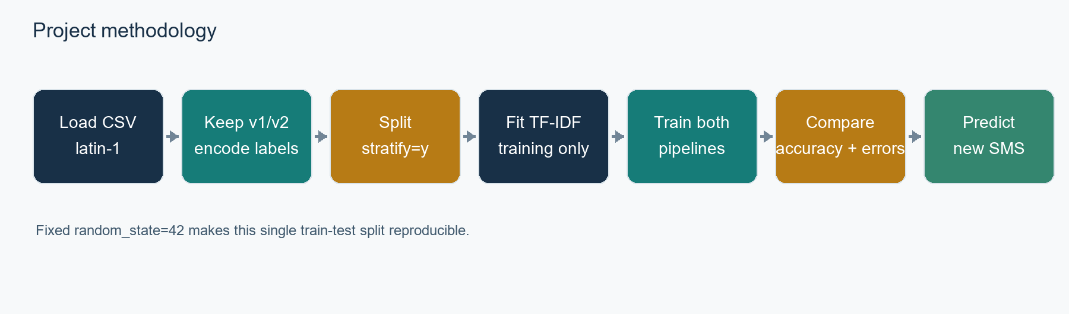
Figure 2. Implemented SMS spam detection methodology.

4. RESULTS, ANALYSIS AND VALIDATION

Implementation of the Solution

The notebook was run in Google Colab using the uploaded spam.csv file. The dataset loaded successfully with 5,572 messages; the label counts were 4,825 ham and 747 spam. The stratified split contained 4,457 training messages and 1,115 test messages, with a 13.4% spam share in each set.
    - Pandas was used to read and prepare the CSV; the code used latin-1 encoding and retained the v1 label and v2 text columns.
    - Scikit-learn pipelines combined TfidfVectorizer(stop_words="english") with MultinomialNB or LogisticRegression(max_iter=1000, random_state=42).
    - The feature vectorizer and classifier were fitted using the training messages; the held-out test set was transformed and evaluated separately.
    - Accuracy, classification reports, and confusion matrices were generated for both models.
    - The notebook selected Naive Bayes for the demonstration because its test accuracy was slightly higher; sample and user-entered messages were also predicted.

Measure | Naive Bayes | Logistic Regression
Accuracy | 96.86% (1080 / 1115) | 96.77% (1079 / 1115)
True ham predicted ham | 966 | 966
Ham falsely flagged as spam | 0 | 0
Spam missed (false negatives) | 35 | 36
Spam correctly caught | 114 | 113
Spam precision / recall | 1.00 / 0.77 | 1.00 / 0.76
Spam F1-score | 0.87 | 0.86

Table 5. Test-set performance and class-level error counts.
Interpretation: Naive Bayes makes one more correct prediction on this split. Both models produced no ham false positives, but each missed some spam. An all-ham baseline would correctly classify 966 of 1,115 messages (86.64%) and miss all 149 spam messages.

Naive Bayes: actual / predicted | Ham | Spam
Ham | 966 | 0
Spam | 35 | 114

Table 6. Naive Bayes confusion matrix; rows are actual labels and columns are predicted labels.

Logistic Regression: actual / predicted | Ham | Spam
Ham | 966 | 0
Spam | 36 | 113

Table 7. Logistic Regression confusion matrix; rows are actual labels and columns are predicted labels.
The spam recall values are calculated from the counts: 114/149 = 76.5% for Naive Bayes and 113/149 = 75.8% for Logistic Regression. Reported classification reports round these values to 0.77 and 0.76.

Test message | Predicted label | Estimated spam probability
Congratulations! You have won a free iPhone. Call now to claim your prize. | Spam | 88.5%
Hi, are we still meeting for lunch today? | Ham | 0.3%
URGENT! You have won a prize. Text WIN to 80085 now. | Spam | 91.9%
Hey, it is Shikhar. | Ham | 1.3%

Table 8. Sample predictions generated by the fitted Naive Bayes model. Estimated probabilities are model scores for these messages.

5. CONCLUSION AND FUTURE WORK

Conclusion

The project demonstrates a complete text-classification workflow for SMS spam detection: CSV preparation, label encoding, a stratified hold-out split, TF-IDF feature extraction, classifier training, evaluation, and predictions for new messages. On the supplied 5,572-message dataset and the 1,115-message test split, Naive Bayes achieved 96.86% accuracy and Logistic Regression achieved 96.77%. Naive Bayes was selected by the notebook’s accuracy rule, but the difference is only one test message. Both models caught most spam with no ham false positives in this particular split, while missing 35 and 36 spam messages respectively. The results are a useful prototype baseline, not a guarantee of performance on new or current SMS traffic.

Future Work

Future work should test the models on newer and more diverse messages, use repeated stratified cross-validation, examine false negatives, and compare TF-IDF with raw word counts or character n-grams. Threshold adjustment and class-sensitive training could be evaluated if the goal is to catch more spam, while measuring the risk of incorrectly blocking legitimate messages. A future interface could allow users to review flagged messages and provide verified labels. Any mobile deployment would require a separate privacy, security, and integration review.

REFERENCES
[7] Scikit-learn developers, “train_test_split,” API Reference. https://scikit-learn.org/stable/modules/generated/sklearn.model_selection.train_test_split.html.
[6] Scikit-learn developers, “LogisticRegression,” API Reference. https://scikit-learn.org/stable/modules/generated/sklearn.linear_model.LogisticRegression.html.
[5] Scikit-learn developers, “MultinomialNB,” API Reference. https://scikit-learn.org/stable/modules/generated/sklearn.naive_bayes.MultinomialNB.html.
[4] Scikit-learn developers, “Feature extraction: Tf–idf term weighting,” scikit-learn User Guide. https://scikit-learn.org/stable/modules/feature_extraction.html.
[3] G. V. Cormack, J. M. Gómez Hidalgo, and E. Puertas Sanz, “Feature engineering for mobile (SMS) spam filtering,” Proceedings of the 30th Annual International ACM SIGIR Conference, pp. 871–872, 2007.
[2] J. M. Gómez Hidalgo, G. Cajigas Bringas, E. Puertas Sanz, and F. Carrero García, “Content Based SMS Spam Filtering,” Proceedings of the 2006 ACM Symposium on Document Engineering, 2006.
[1] T. Almeida and J. Hidalgo, “SMS Spam Collection,” UCI Machine Learning Repository, 2011. doi: 10.24432/C5CC84. https://archive.ics.uci.edu/dataset/228/sms+spam+collection.

    - APPENDIX A. PLAGIARISM REPORT
The institution-issued similarity/plagiarism report was not supplied with the project materials. Attach the official report here after it is generated; no similarity score is asserted in this document.

    - APPENDIX B. DESIGN CHECKLIST
Project title and student details match the submitted assignment.
Dataset is loaded with the correct label and message columns.
Labels are encoded consistently: ham = 0 and spam = 1.
The train-test split is stratified and repeatable.
TF-IDF is fitted only on training messages.
Both classifiers are evaluated on the same held-out test set.
Accuracy, confusion matrices, and spam recall are reported.
Screenshots correspond to the supplied Google Colab run.
Supervisor/examiner signatures and the official similarity report are added by the relevant authority.

APPENDIX C. STEP-BY-STEP COLAB RUN INSTRUCTIONS
1. Open the project notebook in Google Colab and make sure the runtime is connected.
2. Run the first cell and upload the Kaggle SMS Spam Collection file named spam.csv. If downloaded as a ZIP, extract the CSV first.
3. Confirm the notebook reports 5,572 messages: 4,825 ham and 747 spam.
4. Run the train-test split cell and confirm 4,457 training messages and 1,115 test messages, with 13.4% spam in each.
5. Run the model-training cells for Naive Bayes and Logistic Regression.
6. Run the evaluation cell. The supplied run produced 96.86% accuracy for Naive Bayes and 96.77% for Logistic Regression.
7. Run the sample-prediction cells and, if desired, enter a new SMS in the final input cell.
8. When rerunning the notebook, use the results generated by that run rather than copying the values in this report.
COLAB EXECUTION EVIDENCE

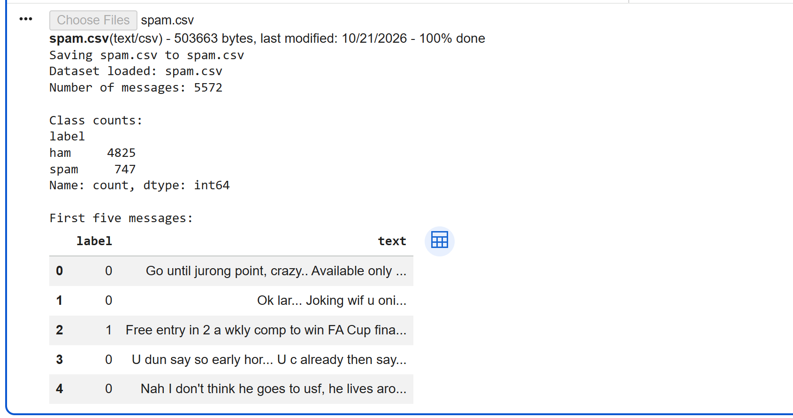  Figure 3. Dataset upload and class counts. | 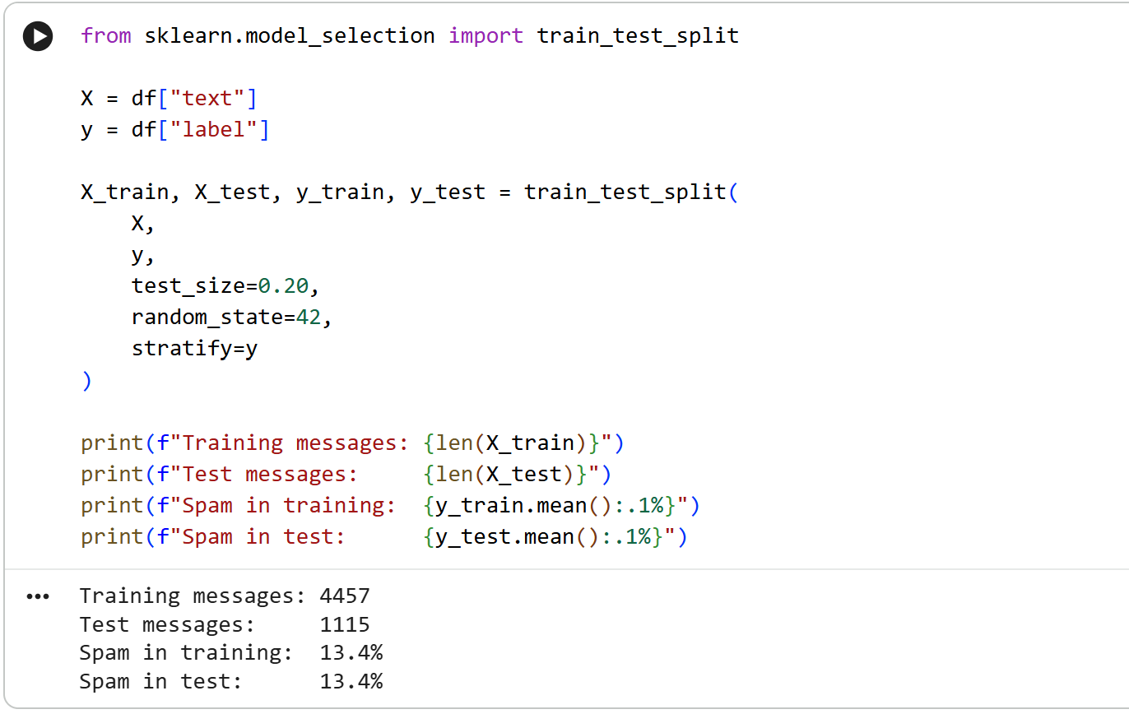  Figure 4. Stratified 80/20 train-test split.
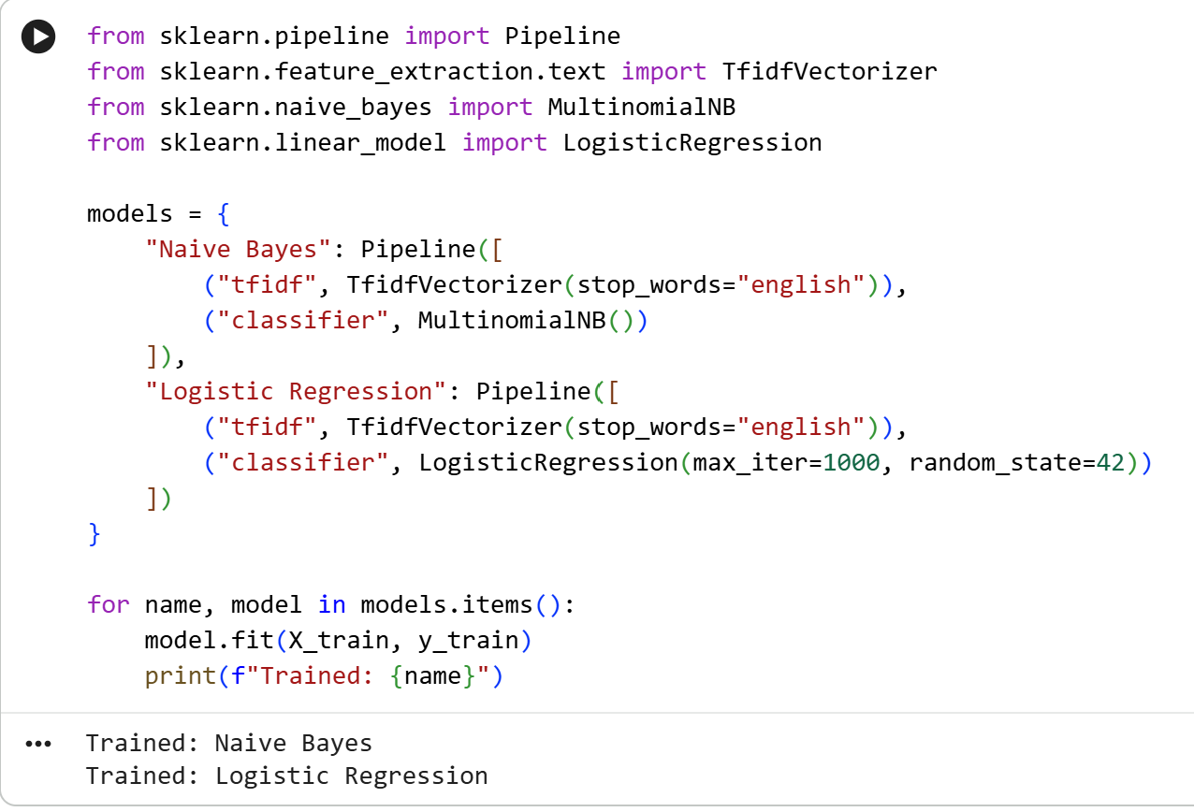  Figure 5. Naive Bayes and Logistic Regression pipeline training. | 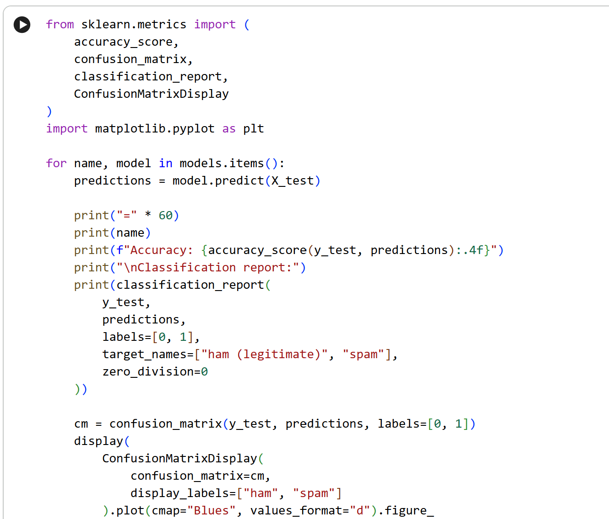  Figure 6. Evaluation code used for accuracy, reports and confusion matrices.

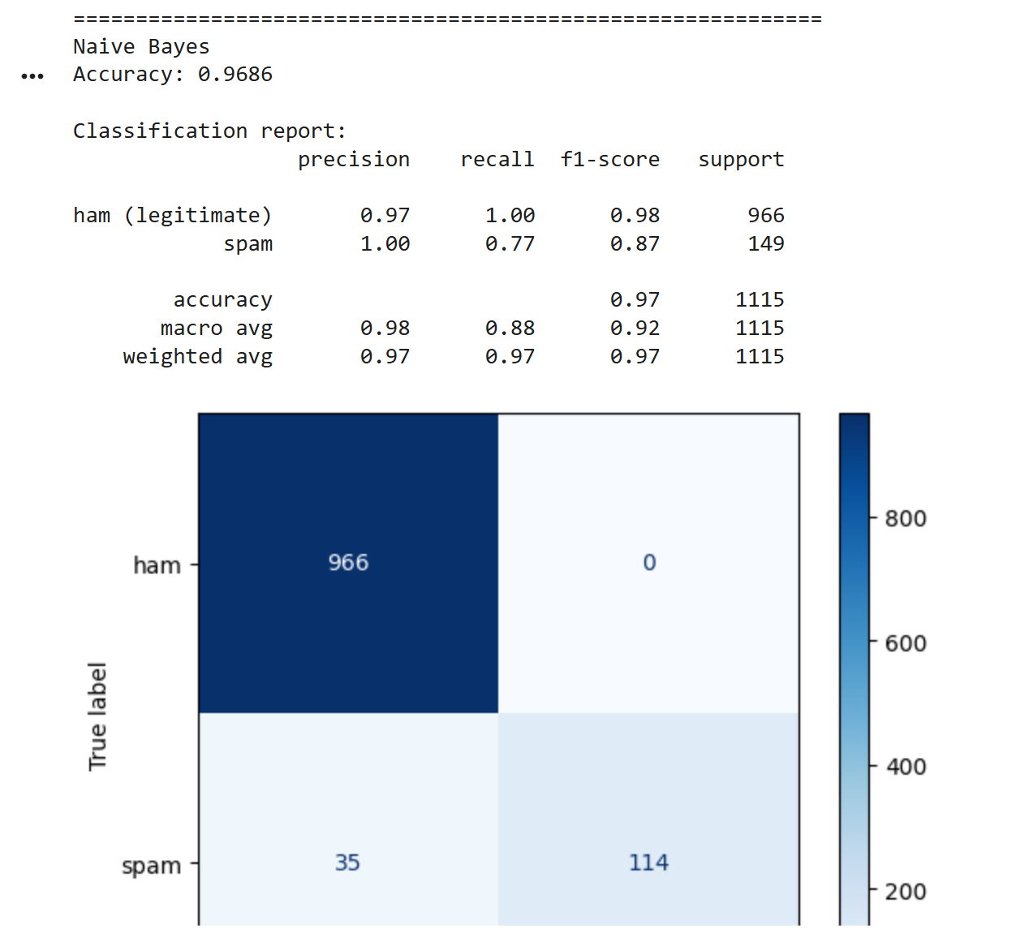  Figure 7. Naive Bayes test results. | 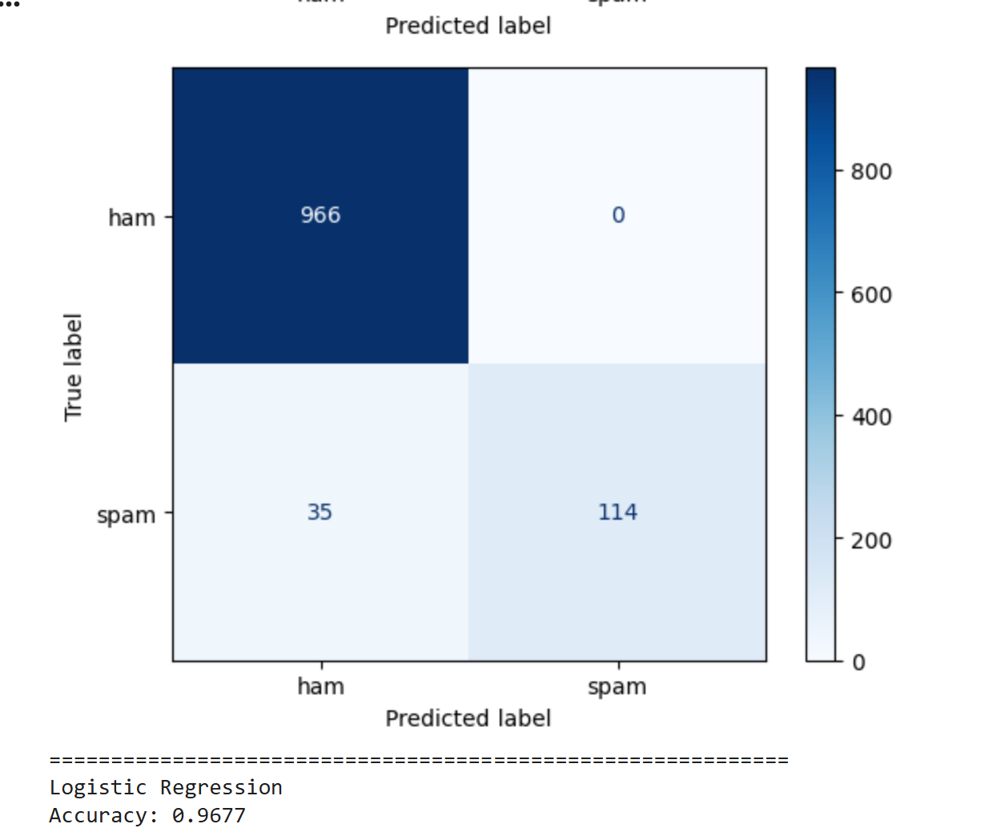  Figure 8. Naive Bayes confusion matrix and Logistic Regression accuracy.
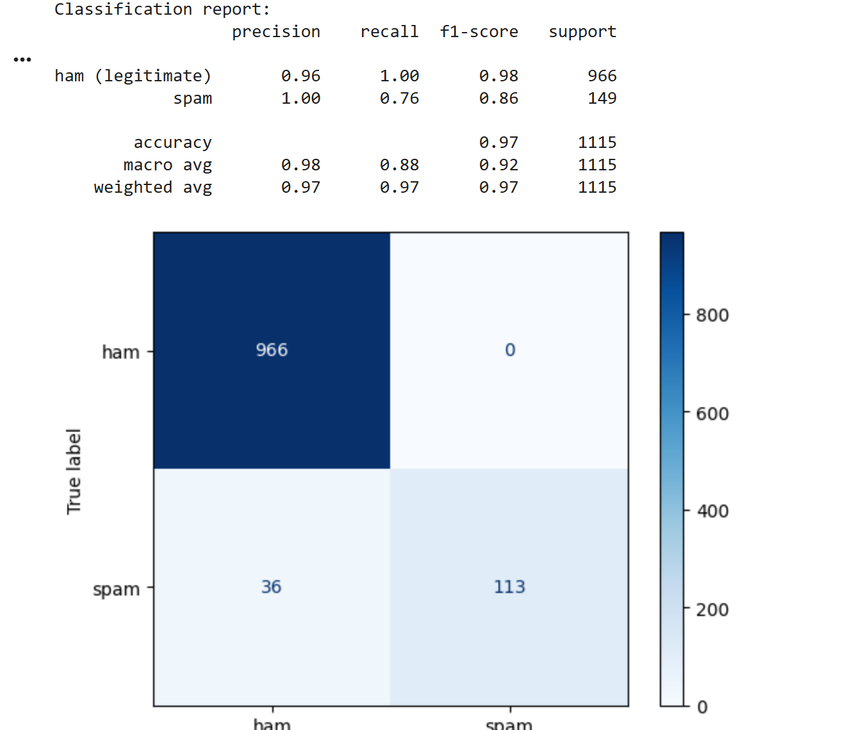  Figure 9. Logistic Regression classification report. | 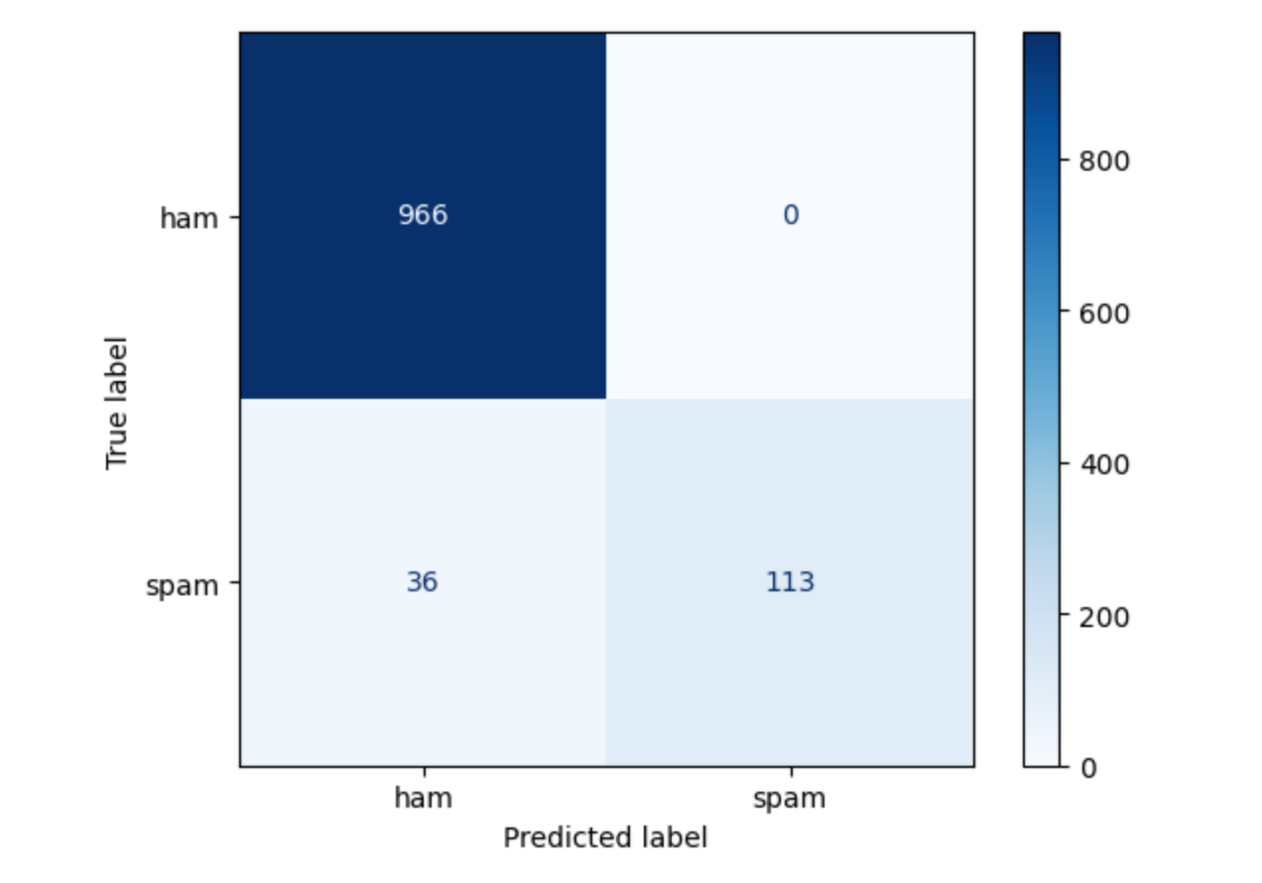  Figure 10. Logistic Regression confusion matrix.

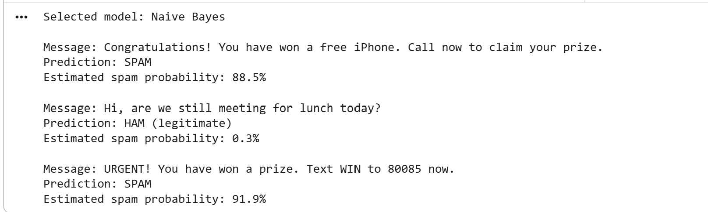  Figure 11. Predictions and estimated spam probabilities for sample messages. | 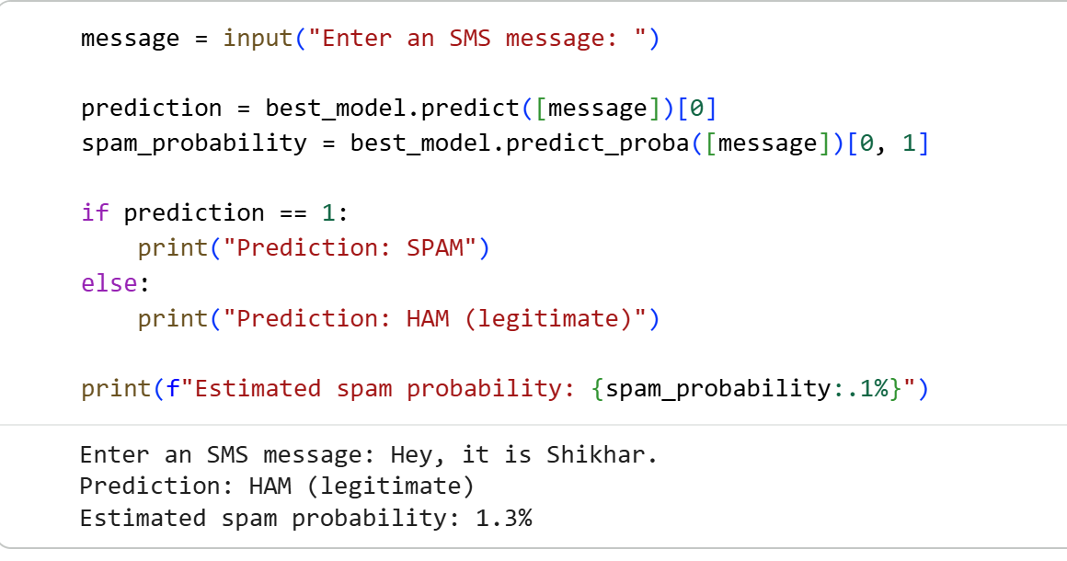  Figure 12. Prediction for a user-entered SMS message.

